1. Before Insertion

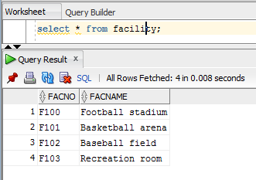

2. Insertion

INSERT INTO Facility (FacNo,FacName)

VALUES ('F104','Swimming Pool');

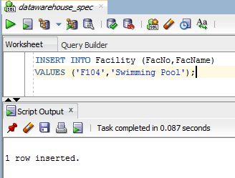

3. After Insertion

